**Artificial Intelligence Lab**

**LAB 7 – Unification and Resolution**

**Aditya Kumar**

**RA1911030010100**

**O2 Section**

**Date – 15/3/22**

**Problem Statement :**

Implementation of unification

**Algorithm :**

1. Initialize the substitution set to be empty.
2. Recursively unify atomic sentences:

* Check for Identical expression match.
* If one expression is a variable vi, and the other is a term ti which does not contain variable vi, then:
* Substitute ti / vi in the existing substitutions
* Add ti /vi to the substitution setlist.
* If both the expressions are functions, then function name must be similar, and the number of arguments must be the same in both the expression.

For each pair of the following atomic sentences find the most general unifier (If exist).

**Code:**

def get_index_comma(string):

index_list = list()

par_count = 0

for i in range(len(string)):

if string[i] == ',' and par_count == 0:

index_list.append(i)

elif string[i] == '(':

par_count += 1

elif string[i] == ')':

par_count -= 1

return index_list

def is_variable(expr):

for i in expr:

if i == '(' or i == ')':

return False

return True

def process_expression(expr):

expr = expr.replace(' ', '')

index = None

for i in range(len(expr)):

if expr[i] == '(':

index = i

break

predicate_symbol = expr[:index]

expr = expr.replace(predicate_symbol, '')

expr = expr[1:len(expr) - 1]

arg_list = list()

indices = get_index_comma(expr)

if len(indices) == 0:

arg_list.append(expr)

else:

arg_list.append(expr[:indices[0]])

for i, j in zip(indices, indices[1:]):

arg_list.append(expr[i + 1:j])

arg_list.append(expr[indices[len(indices) - 1] + 1:])

return predicate_symbol, arg_list

def get_arg_list(expr):

_, arg_list = process_expression(expr)

flag = True

while flag:

flag = False

for i in arg_list:

if not is_variable(i):

flag = True

_, tmp = process_expression(i)

for j in tmp:

if j not in arg_list:

arg_list.append(j)

arg_list.remove(i)

return arg_list

def check_occurs(var, expr):

arg_list = get_arg_list(expr)

if var in arg_list:

return True

return False

def unify(expr1, expr2):

if is_variable(expr1) and is_variable(expr2):

if expr1 == expr2:

return 'Null'

else:

return False

elif is_variable(expr1) and not is_variable(expr2):

if check_occurs(expr1, expr2):

return False

else:

tmp = str(expr2) + '/' + str(expr1)

return tmp

elif not is_variable(expr1) and is_variable(expr2):

if check_occurs(expr2, expr1):

return False

else:

tmp = str(expr1) + '/' + str(expr2)

return tmp

else:

predicate_symbol_1, arg_list_1 = process_expression(expr1)

predicate_symbol_2, arg_list_2 = process_expression(expr2)

# Step 2

if predicate_symbol_1 != predicate_symbol_2:

return False

# Step 3

elif len(arg_list_1) != len(arg_list_2):

return False

else:

# Step 4: Create substitution list

sub_list = list()

# Step 5:

for i in range(len(arg_list_1)):

tmp = unify(arg_list_1[i], arg_list_2[i])

if not tmp:

return False

elif tmp == 'Null':

pass

else:

if type(tmp) == list:

for j in tmp:

sub_list.append(j)

else:

sub_list.append(tmp)

# Step 6

return sub_list

if __name__ == '__main__':

f1 = 'Q(a, g(x, a), f(y))'

f2 = 'Q(a, g(f(b), a), x)'

# f1 = input('f1 : ')

# f2 = input('f2 : ')

result = unify(f1, f2)

if not result:

print('The process of Unification failed!')

else:

print('The process of Unification successful!')

print(result)

**Output:**

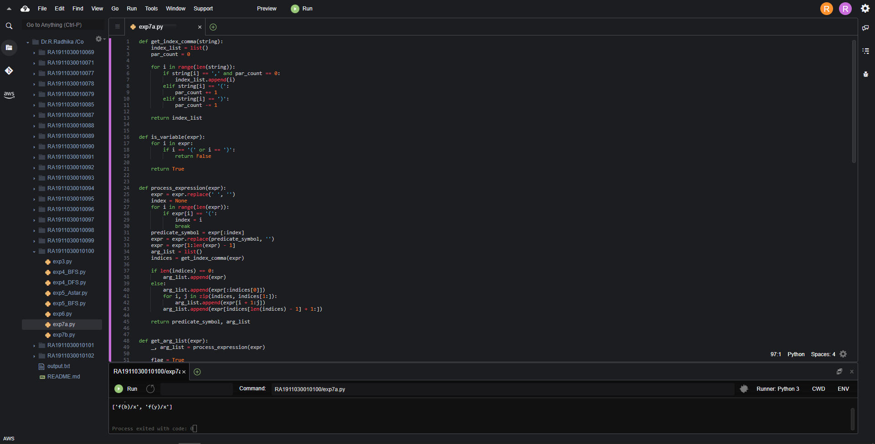

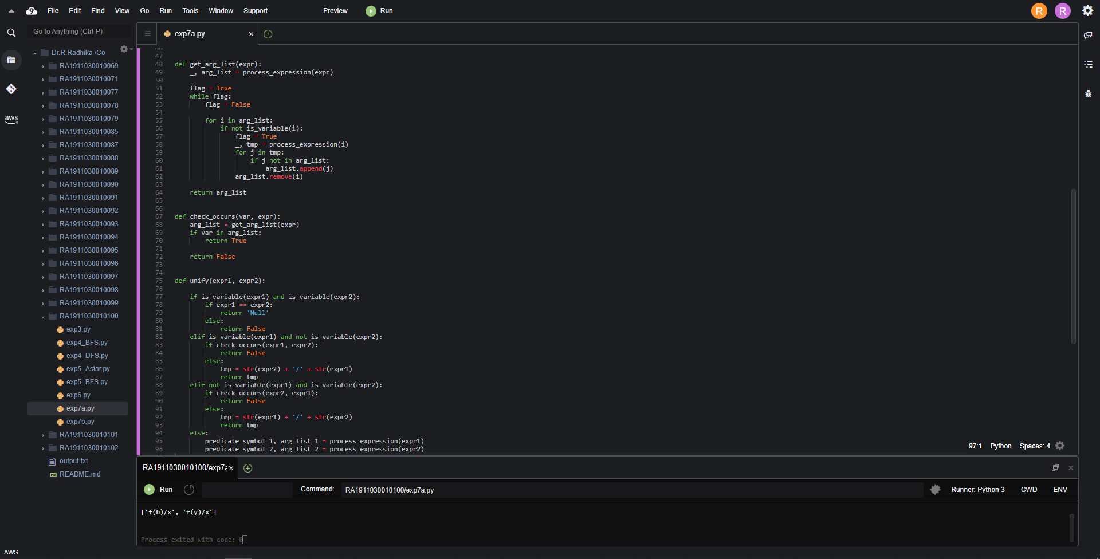

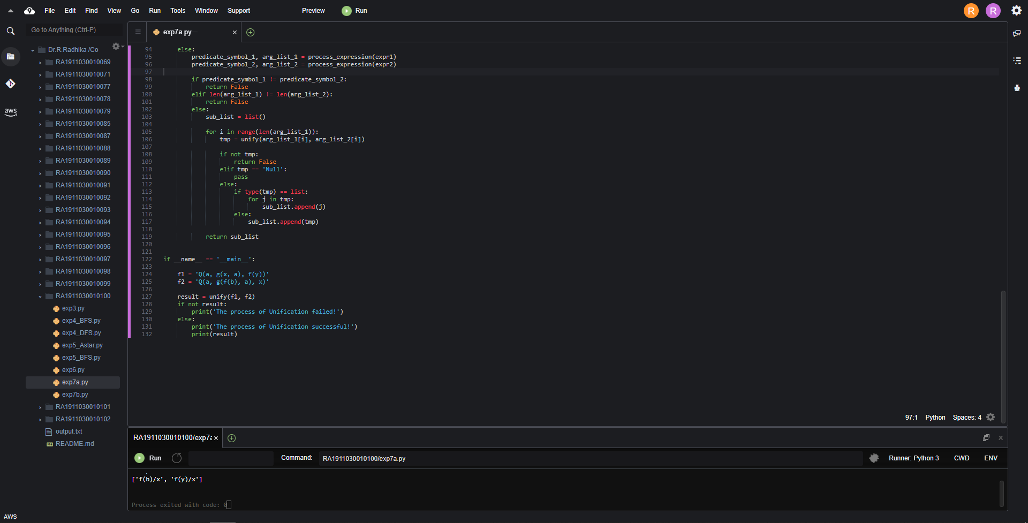

**Result:**

Hence we performed unification.

**Artificial Intelligence Lab**

**LAB 7 – Unification and Resolution**

**Aditya Kumar**

**RA1911030010100**

**O2 Section**

**Date – 15/3/22**

**Problem Statement :**

Implementation of resolution

**Algorithm :**

Resolution is used, if there are various statements are given, and we need to prove a conclusion of those statements. Unification is a key concept in proofs by resolutions. Resolution is a single inference rule which can efficiently operate on the **conjunctive normal form or clausal form.**

1. Conversion of facts into first-order logic.
2. Convert FOL statements into CNF
3. Negate the statement which needs to prove (proof by contradiction)
4. Draw resolution graph (unification).

**Code :**

import copy

import time

class Parameter:

variable_count = 1

def __init__(self, name=None):

if name:

self.type = "Constant"

self.name = name

else:

self.type = "Variable"

self.name = "v" + str(Parameter.variable_count)

Parameter.variable_count += 1

def isConstant(self):

return self.type == "Constant"

def unify(self, type_, name):

self.type = type_

self.name = name

def __eq__(self, other):

return self.name == other.name

def __str__(self):

return self.name

class Predicate:

def __init__(self, name, params):

self.name = name

self.params = params

def __eq__(self, other):

return self.name == other.name and all(a == b for a, b in zip(self.params, other.params))

def __str__(self):

return self.name + "(" + ",".join(str(x) for x in self.params) + ")"

def getNegatedPredicate(self):

return Predicate(negatePredicate(self.name), self.params)

class Sentence:

sentence_count = 0

def __init__(self, string):

self.sentence_index = Sentence.sentence_count

Sentence.sentence_count += 1

self.predicates = []

self.variable_map = {}

local = {}

for predicate in string.split("|"):

name = predicate[:predicate.find("(")]

params = []

for param in predicate[predicate.find("(") + 1: predicate.find(")")].split(","):

if param[0].islower():

if param not in local: # Variable

local[param] = Parameter()

self.variable_map[local[param].name] = local[param]

new_param = local[param]

else:

new_param = Parameter(param)

self.variable_map[param] = new_param

params.append(new_param)

self.predicates.append(Predicate(name, params))

def getPredicates(self):

return [predicate.name for predicate in self.predicates]

def findPredicates(self, name):

return [predicate for predicate in self.predicates if predicate.name == name]

def removePredicate(self, predicate):

self.predicates.remove(predicate)

for key, val in self.variable_map.items():

if not val:

self.variable_map.pop(key)

def containsVariable(self):

return any(not param.isConstant() for param in self.variable_map.values())

def __eq__(self, other):

if len(self.predicates) == 1 and self.predicates[0] == other:

return True

return False

def __str__(self):

return "".join([str(predicate) for predicate in self.predicates])

class KB:

def __init__(self, inputSentences):

self.inputSentences = [x.replace(" ", "") for x in inputSentences]

self.sentences = []

self.sentence_map = {}

def prepareKB(self):

self.convertSentencesToCNF()

for sentence_string in self.inputSentences:

sentence = Sentence(sentence_string)

for predicate in sentence.getPredicates():

self.sentence_map[predicate] = self.sentence_map.get(

predicate, []) + [sentence]

def convertSentencesToCNF(self):

for sentenceIdx in range(len(self.inputSentences)):

# Do negation of the Premise and add them as literal

if "=>" in self.inputSentences[sentenceIdx]:

self.inputSentences[sentenceIdx] = negateAntecedent(

self.inputSentences[sentenceIdx])

def askQueries(self, queryList):

results = []

for query in queryList:

negatedQuery = Sentence(negatePredicate(query.replace(" ", "")))

negatedPredicate = negatedQuery.predicates[0]

prev_sentence_map = copy.deepcopy(self.sentence_map)

self.sentence_map[negatedPredicate.name] = self.sentence_map.get(

negatedPredicate.name, []) + [negatedQuery]

self.timeLimit = time.time() + 40

try:

result = self.resolve([negatedPredicate], [

False]*(len(self.inputSentences) + 1))

except:

result = False

self.sentence_map = prev_sentence_map

if result:

results.append("TRUE")

else:

results.append("FALSE")

return results

def resolve(self, queryStack, visited, depth=0):

if time.time() > self.timeLimit:

raise Exception

if queryStack:

query = queryStack.pop(-1)

negatedQuery = query.getNegatedPredicate()

queryPredicateName = negatedQuery.name

if queryPredicateName not in self.sentence_map:

return False

else:

queryPredicate = negatedQuery

for kb_sentence in self.sentence_map[queryPredicateName]:

if not visited[kb_sentence.sentence_index]:

for kbPredicate in kb_sentence.findPredicates(queryPredicateName):

canUnify, substitution = performUnification(

copy.deepcopy(queryPredicate), copy.deepcopy(kbPredicate))

if canUnify:

newSentence = copy.deepcopy(kb_sentence)

newSentence.removePredicate(kbPredicate)

newQueryStack = copy.deepcopy(queryStack)

if substitution:

for old, new in substitution.items():

if old in newSentence.variable_map:

parameter = newSentence.variable_map[old]

newSentence.variable_map.pop(old)

parameter.unify(

"Variable" if new[0].islower() else "Constant", new)

newSentence.variable_map[new] = parameter

for predicate in newQueryStack:

for index, param in enumerate(predicate.params):

if param.name in substitution:

new = substitution[param.name]

predicate.params[index].unify(

"Variable" if new[0].islower() else "Constant", new)

for predicate in newSentence.predicates:

newQueryStack.append(predicate)

new_visited = copy.deepcopy(visited)

if kb_sentence.containsVariable() and len(kb_sentence.predicates) > 1:

new_visited[kb_sentence.sentence_index] = True

if self.resolve(newQueryStack, new_visited, depth + 1):

return True

return False

return True

def performUnification(queryPredicate, kbPredicate):

substitution = {}

if queryPredicate == kbPredicate:

return True, {}

else:

for query, kb in zip(queryPredicate.params, kbPredicate.params):

if query == kb:

continue

if kb.isConstant():

if not query.isConstant():

if query.name not in substitution:

substitution[query.name] = kb.name

elif substitution[query.name] != kb.name:

return False, {}

query.unify("Constant", kb.name)

else:

return False, {}

else:

if not query.isConstant():

if kb.name not in substitution:

substitution[kb.name] = query.name

elif substitution[kb.name] != query.name:

return False, {}

kb.unify("Variable", query.name)

else:

if kb.name not in substitution:

substitution[kb.name] = query.name

elif substitution[kb.name] != query.name:

return False, {}

return True, substitution

def negatePredicate(predicate):

return predicate[1:] if predicate[0] == "~" else "~" + predicate

def negateAntecedent(sentence):

antecedent = sentence[:sentence.find("=>")]

premise = []

for predicate in antecedent.split("&"):

premise.append(negatePredicate(predicate))

premise.append(sentence[sentence.find("=>") + 2:])

return "|".join(premise)

def getInput(filename):

with open(filename, "r") as file:

noOfQueries = int(file.readline().strip())

inputQueries = [file.readline().strip() for _ in range(noOfQueries)]

noOfSentences = int(file.readline().strip())

inputSentences = [file.readline().strip()

for _ in range(noOfSentences)]

return inputQueries, inputSentences

def printOutput(filename, results):

print(results)

with open(filename, "w") as file:

for line in results:

file.write(line)

file.write("\n")

file.close()

if __name__ == '__main__':

inputQueries_, inputSentences_ = getInput(‘/home/ubuntu/environment/RA1911030010100/input.txt')

knowledgeBase = KB(inputSentences_)

knowledgeBase.prepareKB()

results_ = knowledgeBase.askQueries(inputQueries_)

printOutput("output.txt", results_)

**Output :**

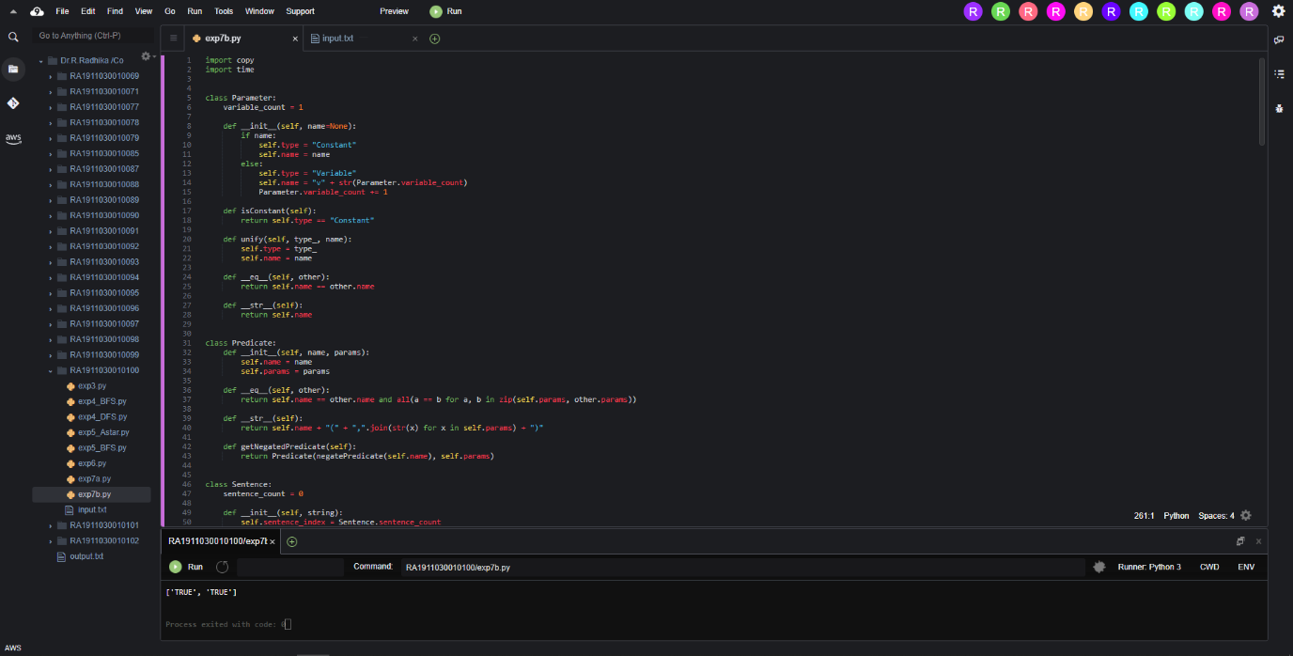

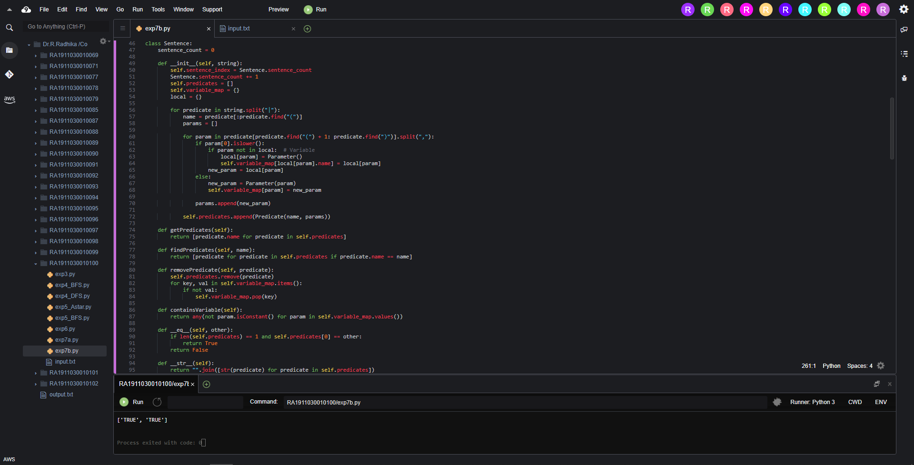

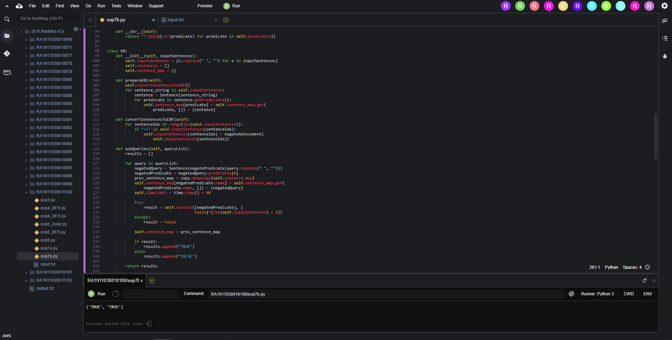

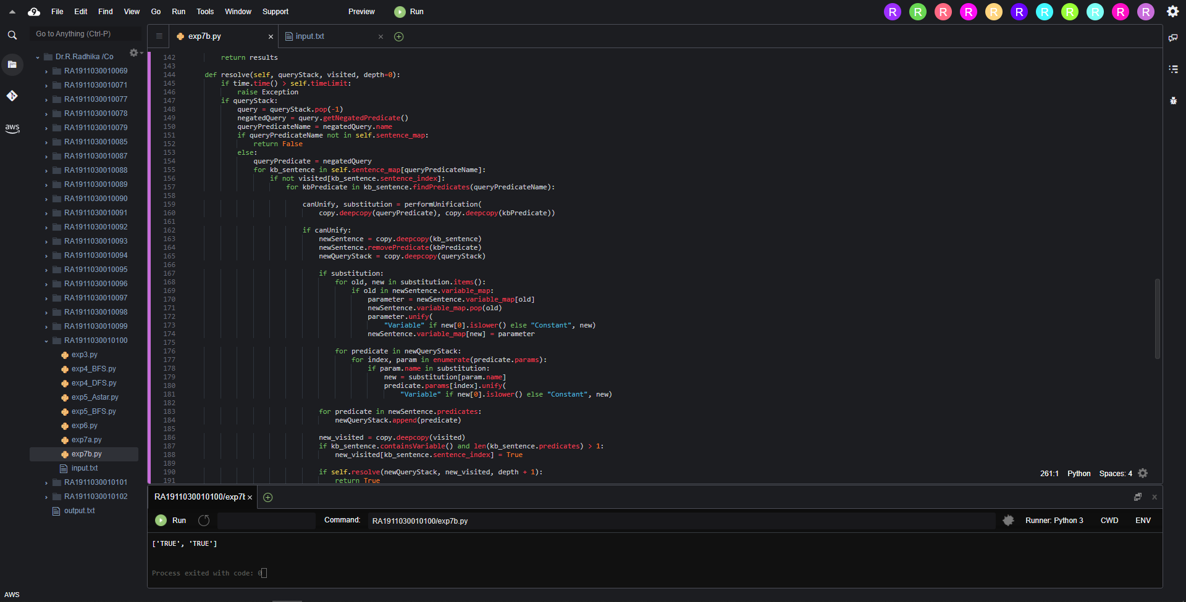

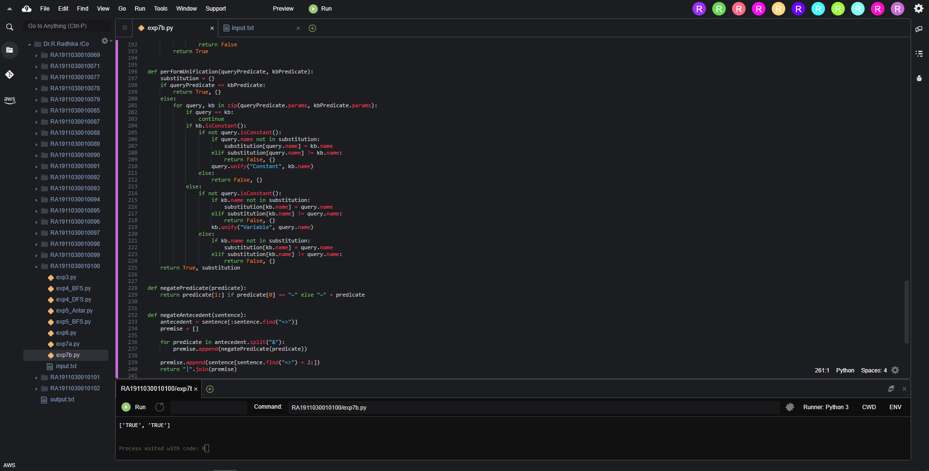

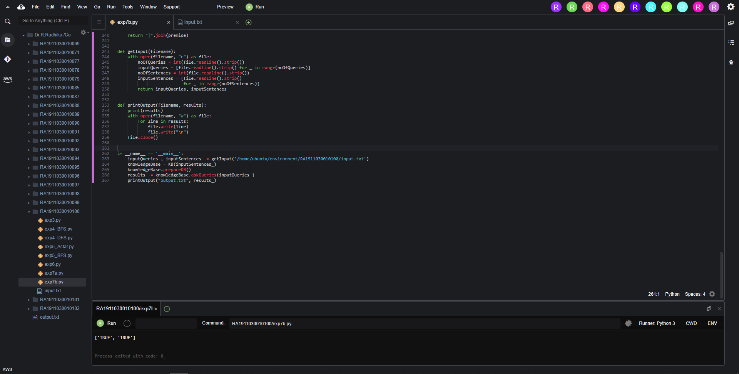

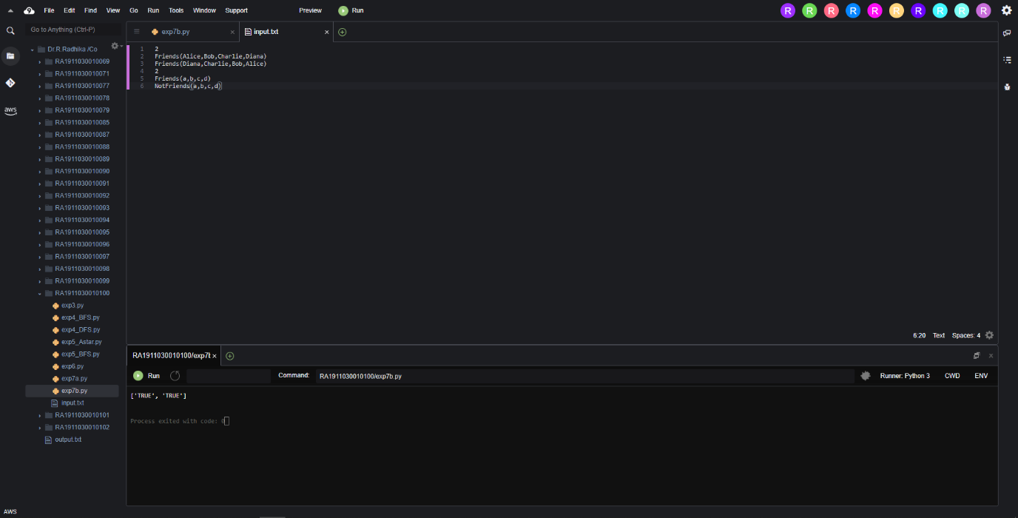

**Result :**

Hence we performed Resolution.